Name: _________________________________________________ Section: ___________ Date: _________
Grade 7 Science Final Review

1) List the steps of the scientific method.

2) What is a variable? An independent variable? A dependent variable?

3) What is an inference? Give an example of an inference.

4) What is an observation? Give an example of an observation.

5) Analyze the following data in the graph to draw a valid conclusion:
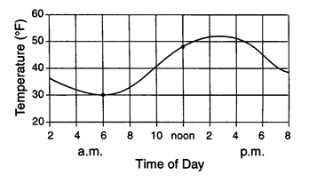

A group of students are testing their “Exit Project” question – “How does type of liquid affect plant growth?” by giving 3 plants different types of liquid. One plant gets water, one plant is given soda, and another plant is given juice. What is the control group in this experiment? List two variables that should be constants.

6) What does the prefix “kilo” mean?

7) Convert the following…
a. 9m = __________cm
b. 10.5cm = ________________ km
c. 45.76m = ____________ km
d. 0.00567 km = ____________ m

8) What is the volume of the liquid in the graduated cylinder below?
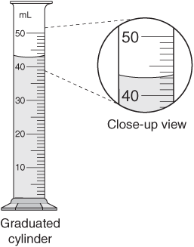

9) The curved line at the top of the liquid is called ______________________________.

10)What is the volume of the object placed in the graduated cylinder below?

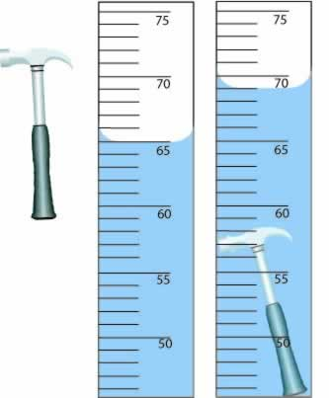

11) What is this measurement technique called?

12) If the mass of the hammer in the diagram above is 10g, what is the density?

13) Explain 2 safety rules that the student in the picture below should follow in order to make his lab set up safer.
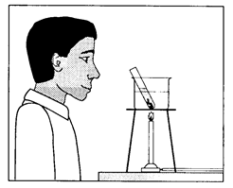

14) Minerals are the building blocks of ___________________.

15) Complete the following chart with mineral properties that can be examined to identify minerals. Write the property/ test in the left hand column and a description in the right hand column.

Mineral Property | Description

16) Complete the following chart about the 3 types of rocks.
 | How it looks/ appearance | How it is formed
Metamorphic
Igneous
Sedimentary

17) What is the difference between physical and chemical weathering? Give an example of each type.

18) Explain how ice can cause weathering of rocks.

19) Complete the chart below with the layers of Earth on the left and a description of each on the right.

20) Explain the causes of earthquakes.

21) Explain the causes of volcanoes.

22) Define the following earthquake-related terms…
Focus-

Epicenter-

Tsunami-

23) What is Pangaea? What evidence do scientists have that Pangaea existed?

24) Name the 3 subatomic particles. State the charge of each.

25) Draw a diagram of an atom with 3 protons, 4 neutrons, and 3 electrons.

26) What is the atomic number of the atom in your diagram?

27) What is the atomic mass of the atom in your diagram?

28) What is the difference between a chemical change and a physical change? Give an example of each.

29) How could you separate a mixture of salt, sand, rocks, and water?

30) What is a compound? Give an example.

31) Define the following terms:
Convergent boundary–

Divergent boundary-

Transform boundary-

32) What info does this box on the periodic table tell us?
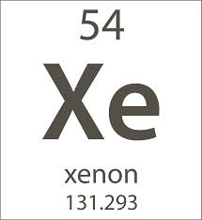

33) Rows on a periodic table are called ______________________________.

34) Columns are called _____________________________.

35.) What are the layers of the skin?
A) epidermis and dermis
B) just dermis
C) subcutaneous
D) epidermis, dermis, and hypodermis
E) hypodermis and dermis

36.) What is the function of the skin?
A) to protect our body from germs and dehydration
B) regulate body temperature
C) protects us against UV radiation
D) all of the above

37.) Which layer of skin contains nerve endings, sweat glands, oil glands, and hair follicles?
A) epidermis
B) dermis
C) hypodermis
D) subcutaneous
E) all of the layers

38.) This layer contains loose connective tissue and has about half of the body's
stored fat.
A) dermis
B) hypodermis
C) epidermis
D) there is no fat in skin

39.) Sebaceous glands secrete
A) sweat
B) milk.
C) oil.
D) scent.

40.) List the three types of muscles.

________________________________________________

________________________________________________

________________________________________________

41.) Which type of muscle is considered a VOLUNTARY muscle?
A) cardiac
B) smooth
C) elongated
D) skeletal

42.) Which type of muscle is NOT striated?
A) cardiac
B) smooth
C) elongated
D) skeletal

43.) Which type of muscle is found in the lining of hollow organs?
A) cardiac
B) smooth
C) elongated
D) skeletal

44.) Which type of muscle is found in the heart?
A) cardiac
B) smooth
C) elongated
D) skeletal

45.) Define the following terms:

voluntary- ___________________________________________________________________________

involuntary- __________________________________________________________________________

46.) Which type of muscle(s) is considered an INVOLUNTARY muscle?
A) cardiac
B) smooth
C) elongated
D) skeletal
E.) both a and b

47.) Which is NOT a function of the skeletal system?
a. | Supports the body | c. | Protects internal organs
b. | Digests food | d. | Allows movement of limbs

____ 48.) The ribs, sternum, skull, and spine are part of what?
a. | Axial skeleton | c. | Bottom of skeleton
b. | Appendicular Skeleton | d. | Outside of skeleton

____ 49.) Which is an example of a LONG bone?
a. | Arm and leg bones | c. | Skull
b. | Wrist and ankle bones | d. | Ribs

____ 50.) Which is NOT an example of a type of joint?
a. | Ball and socket | c. | Circular
b. | Hinge | d. | Pivot

____ 51.) Strong, flexible tissue that makes up soft parts of the body such as the ear and nose is called __________.
a. | Cartilage | c. | Muscle
b. | Vertebrae | d. | Bone
List the flow of air from the mouth/nose to the alveoli. Use the word box to help you.

Word bank: Alveoli, Nose, Trachea, Mouth, Bronchus, Larynx, Bronchioles

52.) Air enters to the body through the _________________________________ and/or ________________________________________.

53.) Then the air will pass through the voice box known as the ______________________________________.

54.) Then the air goes down a long tube known as the ______________________________ which is held open by cartilage.

55.) From there, the tube branches off into two _______________________________________.

56.) These two tubes branch off into smaller tubes known as __________________________________________________________.

57.) The air ends up in small air sacs known as _________________________________________ which are covered with capillaries for gas exchange.

58.) What are four excretory organs in the human body.

59.) What two things might happen if wastes are not removed from the body?

60.) What waste does your skin help get rid of from the body?

61.) Lungs excrete water and what other substance from the body

62.) What waste does your urinary system get rid of?

