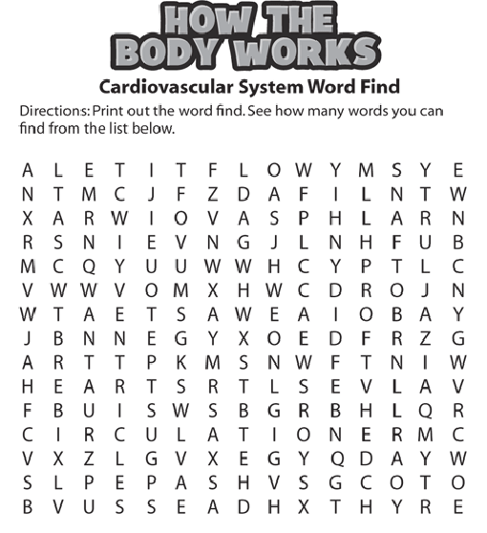
1. These vessels go away from the heart ____________________
2. Top Chambers of the heart ___________________________
3. A stethoscope enables you to hear your heart_____________.
4. Carries O2 and nutrients throughout body ____________________
5. Blood flow throughout the entire body _________________________
6. Pumps blood __________________________
7. Blood carries ____________________ and __________________________
8. Allow blood to pass into different chambers of the heart _______________________
9. Vessels that go TO the heart____________________
10. Bottom chambers ____________________________
11. Blood helps eliminate ______________ from the body.

