Name: ____________________________ Date: _________
Ms. Cyriac/Ms. Sinclair Class: _________

Grade 8 Final Review Sheet

In addition to this sheet, you should study:
- Notes
- Old quizzes
- Old Tests
- Worksheets
- Labs

Part A – Lab Safety

1. List 5 safety rules that should be followed in the lab.

2. List 3 things that unsafe to do in a lab?

Part B – Mass, Volume, Density

3. What is length?

4. What metric units are used for length?

5. What units should be used when measuring shoes and curtains? (cm or meters)

6. What is mass?

7. Name a tool you can use to measure mass?

8. What is the basic unit of mass?

9. List the proper steps when trying to find mass using a triple beam balance.

10. Read the following triple beam balances and record the mass.

- Answer: ______________________

0 10 20 30 40 50 60 70 80 90 100 g

0 100 200 300 400 500 g

0 1 2 3 4 5 6 7 8 9 10 g

- Answer: ______________________
0 10 20 30 40 50 60 70 80 90 100 g

0 100 200 300 400 500 g

0 1 2 3 4 5 6 7 8 9 10 g

11. What formula would you use to find the mass of an object when you know the density and volume?

12. What is volume?

13. What is the base unit of the volume of liquid? The base unit of an object?

14. What tool would you use to measure an approximate volume of a liquid?

15. What tool would you use to measure and accurate volume of liquid?

16. What formula do you use to find the volume of a “regular” shaped object?

17. What procedure do you follow to find the volume of an “irregular” shaped object?

18. What formula do you use to find the volume of an object when you know the objects density and mass?

19. Read the following graduated cylinders and record the volume of the object:
a.
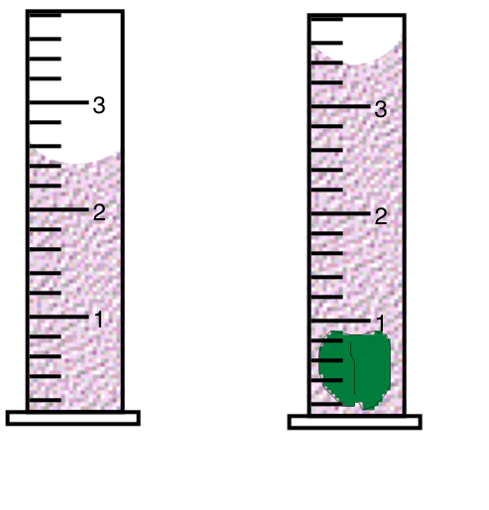
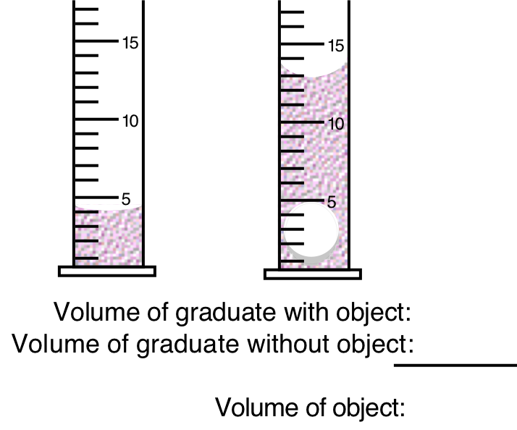

20. What is density?

21. What is the formula for density?

22. What units do you use to express the density of an object?

Part C – Scientific Method

23. List the steps of the Scientific Method in order and describe each of them.
1.

2.

3.

4.

5.

6.

24. What is the Independent Variable?

25. What axis do you plot the independent variable on a graph?

26. What is the dependent variable?

27. What axis do you plot the dependent variable on a graph?

28. What is a control?

29. What are constants?

Part D – Metric System

Know your metric steps!
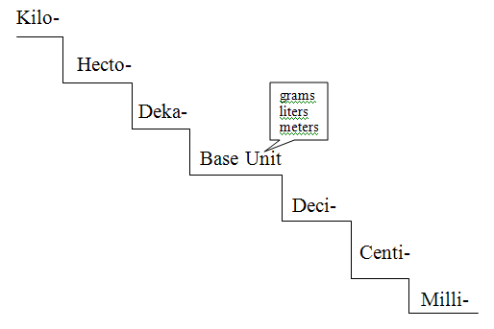
Practice Problems:
- 35.0 km = ___________________ m

- 467.5 dm = ________________ mm

- 4,0000.0 g = _________________ kg

- 84.57 L = _________________ mL

Part E – Genetics and DNA

30. What is the difference between a genotype and a phenotype?

31. What is the difference between homozygous and heterozygous?

32. How would you define heredity?

33. What is the relationship between genes, DNA, and chromosomes?

34. A form of a gene is called an _______________________.

35. What is the difference between a dominant and recessive gene?

36. Create a Punnett square to determine the genotype and phenotypes of Parent A who has homozygous tall genes and Parent B who has heterozygous tall genes.

37. Using your Punnett square that you created for the previous questions, state what would be the percentage of the offspring being tall and what would be the percentage of the offspring being short.

38. Create a dihybrid cross for: Tt x BB

39. What are the four bases of DNA?

40. How are the bases paired up?

41. Write down the complimentary base pair to the following DNA strand:
A-T-G-T-G-C-T-A-G-A-T-C

42. How much force is needed to accelerate a 66 kg skier at 2 m/sec²?

43. What is the force on a 1000 kg elevator that is falling freely at 9.8 m/sec²?

44. What is the acceleration of a 50 kg object pushed with a force of 500 newtons?

45. The mass of a large car is 1000 kg. How much force would be required to accelerate the car at a rate of 3 m/sec²?

46. You arrive in my class 45 seconds after leaving math which is 90 meters away. How fast did you travel?

47.) If a car travels 400m in 20 seconds, how fast is it going?

48.) How did the universe begin?
a.) as a violent explosion
b.) as a violent expansion
c.) from a black hole
d.) from two meteors hitting each other

49.) Which four letters represent Jovian planets on the solar system diagram shown?

a.) A, B, C, D
b.) B, C, D, E
c.) E, F, G, H
d.) F, G, H, I

50.) Which is a difference between the outer planets and the inner planets?
a.) the outer planets have many moons
b.) the outer planets orbit in a different direction
c.) the outer planets have a higher density
d.) the outer planets have a smaller diameter

51.) Which Jovian planets have rings?
a.) Saturn only
b.) Saturn and Neptune
c.) Saturn, Neptune and Uranus
d.) Saturn, Neptune, Uranus, and Jupiter

52.) Because of its rotation, a Neptune _____________________ is __________________ than that of one on Earth.
a.) day; longer
b.) year; longer
c.) day; shorter
d.) year; shorter

53.) Which chemical or gas produces a green-blue to blue color in Uranus and Neptune?
a.) oxygen
b.) carbon dioxide
c.) methane
d.) sulfur dioxide

54.) What is Saturn’s most prominent feature?
a) moon system
b.) ring system
c.) giant storm
d.) liquid oceans

Drawing Moon Phases

For numbers 55-62, shade in the correct order of the phases of the moon and name each phase on the left. Start with the new moon.

55.)
_______________________

56.)
_______________________

57.)
_______________________
58.)
_______________________
59.)
_______________________
60.)
_______________________
61.)
_______________________
62.)
_______________________

63.) What are some characteristics of a star?

a.) mass
b.) size
c.) temperature
d.) color
e.) all of the above

64.) A star is made out of mainly which two elements?

a.) carbon and oxygen
b.) hydrogen and helium
c.) hydrogen and oxygen
d.) helium and carbon

65.) What is nuclear fusion?

a.) carbon atoms fuse together to produce oxygen in which energy is released
b.) helium atoms fuse together to produce hydrogen in which energy is released
c.) oxygen atoms fuse together to produce carbon in which energy is released
d.) hydrogen atoms fuse together to produce helium in which energy is released

66.) _____________________ stars are your hottest stars and _______________________ stars are your coolest stars.

a.) blue; red
b.) red; blue
c.) yellow, white
d.) yellow; red

67.) A star’s brightness as seen from Earth is known as ____________________.

a.) Luminosity
b.) Magnitude
c.) Absolute Brightness
d.) Apparent Brightness

68.) What is a constellation?

a.) a star coming to the end of its life
b.) a star going through nuclear fusion
c.) a group of stars that form a shape which is later named
d.) stars engulfing planets

You must be able to understand and complete all questions of this review sheet!

Parent Signature Student Signature

________________ ________________

