Muscular System Note Sheet Name: _____________________________ Period: _____________
Ms. Cyriac

1. What do muscles do?
a.
b.
c. voluntary –
ex. Shooting a basketball, playing a piano, etc.
d. involuntary –
ex. Muscles that help you breathe, make your heart beat

2. 3 Types of Muscles
a. Smooth Muscle –

- found inside digestive tract, lining of blood vessels

- INVOLUNTARY- you cannot control the movement!

b. Skeletal Muscle –

- VOLUNTARY control

- Flexor –
- Extensor –
- a great example is when you bend and straighten your arm at the elbow using your biceps and triceps.

c. Cardiac Muscle –

- responsible for the contraction of your heart
- INVOLUNTARY!

3. Properties of Muscles
a. ___________________________________- muscles have the ability to shorten, or contract
b. ___________________________________- muscles lengthen

4. How do you build strong muscles?
a.
b.
ex. Meats, milk, eggs, yogurt, fish, nuts
c.

5. Muscular System Problems
1. Muscle Strain
a.
b. to heal-
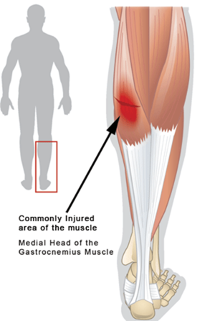

2. Muscle Cramp
a.
b.
c. to heal – gently stretch the muscle and massage the knot

3. Muscular Dystrophy
a.
b.
c. symptoms – muscle weakness, difficulty standing/walking, frequent falling
d. cannot be cured, but early detection is key as muscle weakening can be delayed

6.) Muscle Size
a. ___________________________________- increase in muscle size due to exercise
b. ___________________________________- decrease in muscle size from a lack of use of muscles

Diagram of the Muscular System

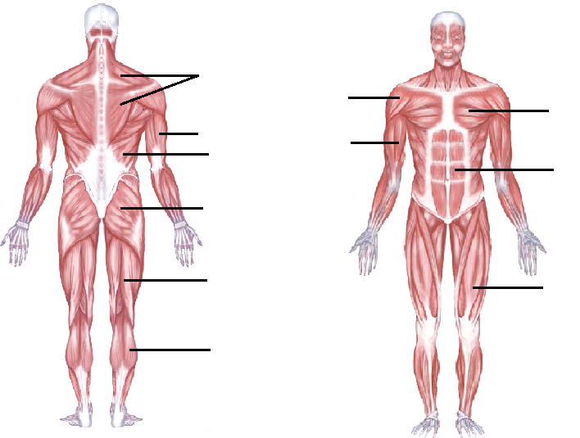
Rectus
Abdominis
Trapezius
Gastrocnemius
Hamstring
Gluteus Maximus
Triceps
Quadriceps
Deltoid
Biceps
Pectoralis

